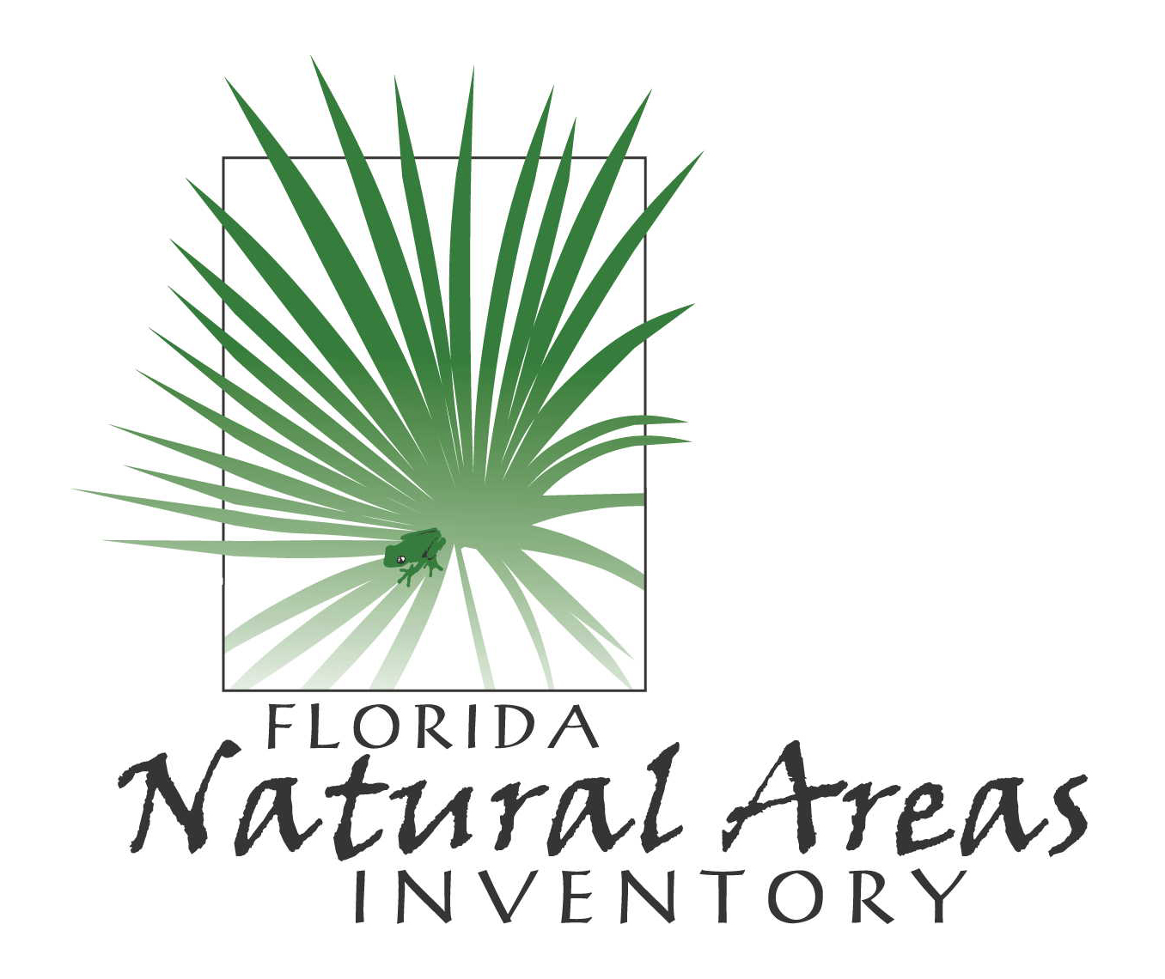
FLORIDA NATURAL AREAS INVENTORY

Field Report Form for Occurrences of Rare Plants, Animals, and Natural Communities

Report original field observations regarding a single species or community, at one location, and for (preferably) a single date. Use the back of the form or other sheets as necessary, and if you have any questions please call FNAI at 850-224-8207.

Please send completed form to: Florida Natural Areas Inventory, 1018 Thomasville Rd., Suite 200-C, Tallahassee, FL 32303 THANK YOU!

Note - you may use the tab key or the cursor to move between the fields of this form.

REQUIRED DATA
Your name: Phone: E-mail:
Address:
Name of observer(s):
Date of observation (m/d/yyyy):
Scientific name: Common name (only if scientific name is not known):
Basis for identification: Personal knowledge Reference key Field guide Museum specimen Expert Other method
Name of reference key/guide/museum/expert: Other ID method:
County:
Latitude N Longitude W (if unknown, please attach to this form a map or detailed verbal description of the location)
Quantity seen (number of individuals, nests, burrows, or clumps, etc., or area occupied):

FNAI will include the location of this occurrence in publicly available data products unless you specifically request that we do not. If you want to make this request, please provide your reason for regarding the data “sensitive” (e.g. species subject to collection)

OPTIONAL DATA (all of the information below is optional – enter as time and data resources permit)
IDENTIFICATION
Photograph taken? Yes No (If possible, please attach a copy of the photo)
Specimen collected? Yes No Deposited at museum/herbarium? Yes No Repository: collection #:
Do you think your identification requires confirmation? Yes No

LOCATION
Site or place name, if known:
Precise directions to the occurrence that use a readily locatable and relatively permanent landmark on or near the site (such as a road intersection, bridge, or natural landform) as the starting point. Include distances and directions from landmarks, as appropriate. Please note – neither the directions nor the coordinate information will be provided to the general public if the data are to be considered sensitive, as indicated above.

For latitude/longitude only: Datum: NAD27 WGS84/NAD83 Unknown
Source of latitude/longitude coordinates? GPS Other If other, describe
If GPS: Make model accuracy m DGPS? Yes No Unknown WAAS? Yes No Unknown

If possible, mark the site on a copy of an aerial photograph or a USGS 7.5’ topographic map and attach to this form. Otherwise, please provide a sketch of the vicinity showing the occurrence in relation to towns, roads, landforms, water bodies, and other natural features, including ecological communities. Please also include an indication of scale and a North arrow.

OBSERVATION INFORMATION
Time of day Estimate of total area observed m² or acres. Percent of this area actually occupied by the population or community: %. Approximate dimensions of the area occupied: length m width m
How did you collect the data? (e. g., visually observed from road, trap or capture methods, walking a path through community, formal survey, etc.)
Is there other suitable habitat (unobserved) in the vicinity? Yes No Don’t know Extent? (e.g., acres, miles)
Have you been to this location before? Yes No If so, when?
Did you previously observe this species or community? Yes No Did not look for it If you have previously seen the population or community, do you think there is now more? less? about the same amount as before? or no way to compare .

General description. Please provide a description or “word picture” of the area where this occurrence is located (i.e., the physical setting and
ecological context), including habitat, dominant plant species, topography, hydrology, soils, adjacent communities, and surrounding land use.

For animals: Estimated total no. of individuals in population: Basis? Age structure
Ecological & behavioral notes (e.g. reproductive stage, activity type [feeding, flying, nesting, etc.]):

For plants: Flowering? Yes No Fruiting? Yes No In bud? Yes No In leaf? Yes No Dormant? Yes No

For communities: For each of three strata (tree, shrub, and ground layers), please list the dominant species comprising the stratum, together with an estimate of the height and percent cover for each stratum.
Stratum height % cover Species
Tree
Shrub
Ground

Describe species dominance relationships, vegetation heterogeneity, succession stage/dynamics, and any other unique aspects of the community or additional noteworthy species (including animals).

MANAGEMENT
Owner of site (if known):
Is the owner or manager protecting or managing the property for this species or community? Yes No Don’t know
Are there disturbances or threats (e. g., urban development, agriculture, vehicle use, forestry, logging, fire suppression, ditching/draining, impoundment, exotic species, and natural disturbance) in the vicinity of the site? Yes No Don’t know

If so, please describe type and severity:

Is there evidence (e.g., fire breaks, scorching) of the use of fire at the site? Yes No Don’t know Describe and give dates of recent fires, if known

Comments on management history or needs:

OTHER
Additional comments concerning the population or community, its ecological conditions, contact information for other knowledgeable people, etc.:

